Security by hardware
Replacing cryptographic software solution with a HSM

Table of Contents

1 Case description 3
2 Project goal 3
3 Project objectives 3
4 Requirements 3
4.1 Non-functional requirements 3
4.2 Functional requirements 4

Case description
Company T manufactures utility drones for urban environments. Currently, the company is investigating the possibility of using drones to monitor tree health and detect various plant pests. One of the key ideas is to develop a system that can autonomously recognize oak processionary caterpillars on trees using a drone equipped with both optical and thermal imaging.

Project goal
Based on the case description and discussions with the project lead, the following goal has been established:
The goal of this project is to design, develop, test & integrate an autonomous detection system for oak processionary caterpillars using drones, leveraging dual-spectrum (visible and thermal) imaging, AI-based detection, and real-time processing to ensure high-accuracy identification and monitoring.

Project objectives
The project’s objectives have been formulated after an initial study of technical documentation and interviews with stakeholders. The objectives are:
- Develop a dual-spectrum detection system combining visible and thermal imaging to improve caterpillar detection accuracy.
- Train an AI-based object detection model using a custom dataset with a minimum of 10,000 labeled images.
- Integrate the detection pipeline with the onboard NVIDIA Jetson Xavier NX computing platform for real-time inference at 10FPS.
- Implement an adaptive flight path planning algorithm to optimize drone scanning efficiency based on detected caterpillar nests.
- Ensure seamless DJI SDK and ROS2 integration for drone control and data processing.
- Perform extensive field testing, evaluate detection performance, and document the results.

Requirements
For eliciting the requirements, the following sources have been used:
• An interview with the CTO, conducted on 2024-12-03
• The technical specifications of DJI Matrice 300 RTK and camera payloads
• The API documentation of DJI SDK and ROS2 framework
• Stakeholder interviews with software engineers and vision engineers

Non-functional requirements

ID: NF-DET-01 | Dual-spectrum detection | Type: SHALL
Requirement | The system shall use both optical and thermal imaging for accurate caterpillar detection.
Reason | Ensuring high detection accuracy, especially under varying lighting conditions.
Verification | Component tests, field trials | T-DET-2
Related to | F-DET-01 | 2025-02-11

Functional requirements

ID: F-DET-02 | Adaptive path planning | Type: SHALL
Requirement | The system shall dynamically adjust the drone’s flight path based on detected caterpillar nests.
Reason | Maintaining compatibility and certifiability.
Verification | Simulation, field tests | CR-FLT-9, T-UT-231
Related to | F-DET-01 | 2025-02-11

ID: F-DET-01 | AI-based detection | Type: SHALL
Requirement | The system shall implement an AI-based object detection model trained with at least 10,000 labeled images.
Reason | Ensuring robust and reliable caterpillar recognition.
Validation | Demonstration, code inspection, unit tests | T-DET-1, CR-DET-1, T-UT-2
Related to | NF-DET-01 | 2025-02-11

Work Breakdown

Based on the requirement analysis and the deliverables defined in the project, the following work breakdown was devised. The WBS covers all the deliverables.

WBS list

Notice: Your WBS list should be more detailed than this one and include the breakdown into at least level-2 tasks:

1. Project Initiation
1.1 Stakeholder requirements analysis
1.2 Project charter development
1.3 Team formation

2. Research
2.1 Caterpillar thermal signature analysis
2.2 Existing solutions review
2.3 Sensor technology evaluation
2.4 Dataset requirements analysis

3. System Design
3.1 Architecture design
3.2 Camera system configuration
3.3 Flight pattern optimization
3.4 Thermal-visible registration approach

4. Software Development
4.1 Core Components
4.1.1 DJI SDK integration
4.1.2 ROS2 bridge development
4.1.3 CUDA acceleration
4.2 Detection Algorithm
4.1.1 YOLOv8 customization
4.1.2 TensorRT engine implementation
4.1.3 Multi-spectrum fusion
4.3 Data Processing Pipeline
4.3.1 Pre-processing module
4.3.2 Real-time inference (10FPS)
4.3.3 Post-processing

5. Dataset Development
5.1 Data collection planning
5.2 Image acquisition
5.3 Labeling (10,000+ images)
5.4 Augmentation pipeline

6. Testing & Validation
6.1 Unit testing
6.2 Integration testing
6.3 Field testing
6.4 Performance validation (20m/95% confidence)

7. Deployment
7.1 Edge deployment configuration
7.2 Model update mechanism
7.3 Flight control integration

8. Documentation
8.1 Technical documentation
8.2 User manuals
8.3 API documentation
8.4 Maintenance guides

WBS diagram

Notice: Your WBS diagram should be more detailed than this one and include the breakdown into at least level-2 tasks. In the example diagram only Common API and Documentation contain level-2 tasks.

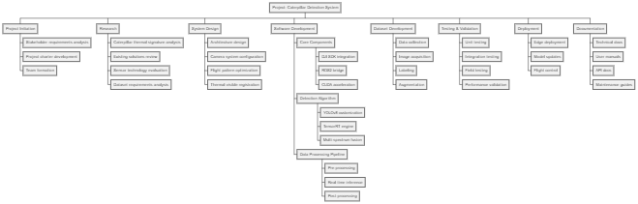
Figure 1. WBS diagram of the task in the project.
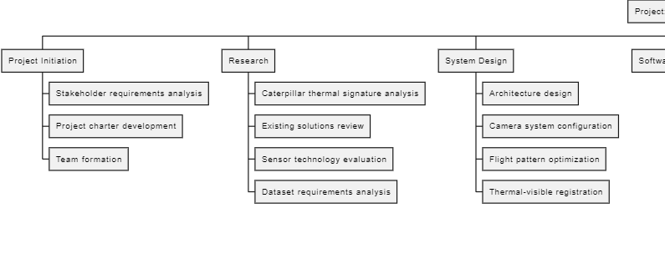
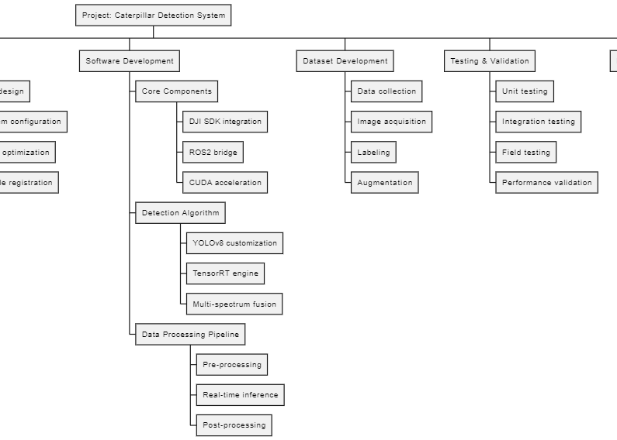
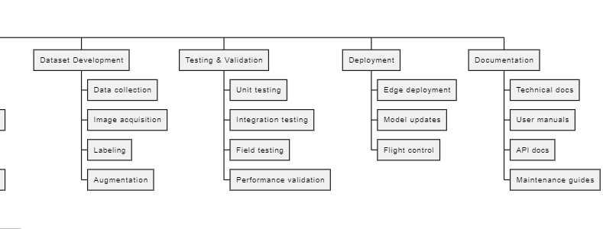

Effort estimation and planning

Effort estimation

Notice: include effort estimation of all top-level tasks. If some tasks need more detailing, include estimates of sub-tasks.

Table 1. Time effort estimation of the tasks in hours.
Task | Sub-Task | Pessimistic | Most Likely | Optimistic | PERT
Project Initiation | - | 40 | 30 | 20 | 30
Research | Thermal analysis | 50 | 40 | 30 | 40
 | Solutions review | 30 | 20 | 15 | 21
 | Sensor evaluation | 40 | 30 | 20 | 30
 | Dataset analysis | 30 | 20 | 15 | 21
System Design | Architecture | 60 | 40 | 30 | 42
 | Camera config | 40 | 30 | 20 | 30
 | Flight patterns | 50 | 40 | 30 | 40
 | Registration | 70 | 50 | 40 | 52
Software Dev | Core components | 120 | 90 | 60 | 90
 | Detection algo | 200 | 150 | 100 | 150
 | Data pipeline | 150 | 120 | 80 | 117
Dataset Dev | Collection | 80 | 60 | 40 | 60
 | Acquisition | 100 | 80 | 60 | 80
 | Labelling | 200 | 150 | 100 | 150
 | Augmentation | 60 | 40 | 30 | 42
Testing | Unit tests | 60 | 40 | 30 | 42
 | Integration | 80 | 60 | 40 | 60
 | Field tests | 120 | 100 | 80 | 100
 | Validation | 100 | 80 | 60 | 80
Deployment | Edge config | 60 | 40 | 30 | 42
 | Model updates | 50 | 40 | 30 | 40
 | Flight control | 70 | 50 | 40 | 52
Documentation | Tech docs | 80 | 60 | 40 | 60
 | User manuals | 60 | 40 | 30 | 42
 | API docs | 50 | 40 | 30 | 40
 | Maintenance | 40 | 30 | 20 | 30

Planning

Notice: Use the PERT estimates for making the Gannt chart. It doesn’t have to be ideal but try to do your best.

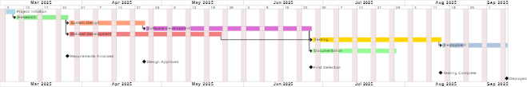
Figure 2. Gannt chart with the schedule of the project.

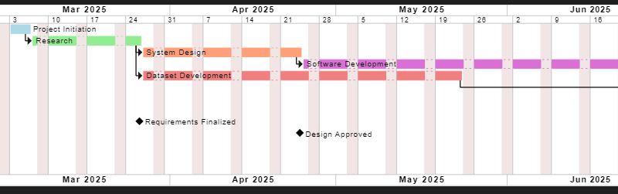
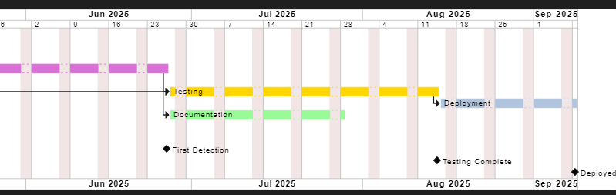

15 different risk events identified, risk analysis & prioritization, and risk mitigation plan and upload it here
- Risk Events, Prioritization, and Mitigation Plan
(Categorized by Dimension)
1. Technical Risks
1.1 Thermal-Visible Image Misalignment
- Likelihood: Medium (3/5)
- Impact: High (4/5)
- Rationale: Calibration errors due to drone motion or environmental factors.
- Mitigation: Implement dynamic registration algorithms and in-field calibration checks.
1.2 TensorRT Engine Failures
- Likelihood: Low (2/5)
- Impact: High (4/5)
- Rationale: Compatibility issues with custom YOLOv8 model.
- Mitigation: Test engine conversions rigorously; maintain fallback CPU mode.
1.3 Motion Blur at High Speeds
- Likelihood: High (4/5)
- Impact: Medium (3/5)
- Rationale: Blur degrades detection accuracy above 6m/s.
- Mitigation: Limit speed to 5m/s; use deblurring filters (e.g., Wiener filter).
2. Operational Risks
2.1 Battery Depletion Mid-Flight
- Likelihood: Medium (3/5)
- Impact: Critical (5/5)
- Rationale: Extended flight time for adaptive path planning.
- Mitigation: Reserve 20% battery for return; use predictive battery models.
2.2 Payload Overload
- Likelihood: Low (2/5)
- Impact: High (4/5)
- Rationale: Adding thermal camera exceeds 2.7kg limit.
- Mitigation: Optimize component weight; test payload balance pre-flight.
2.3 GPS Signal Loss
- Likelihood: Low (2/5)
- Impact: High (4/5)
- Rationale: Urban canyon effect disrupts RTK positioning.
- Mitigation: Use vision-based SLAM as backup.
3. Data Risks
3.1 Insufficient Training Data
- Likelihood: High (4/5)
- Impact: High (4/5)
- Rationale: <10k labeled images reduces model accuracy.
- Mitigation: Synthetic data generation; collaborate with forestry agencies.
3.2 Thermal Signature Variability
- Likelihood: Medium (3/5)
- Impact: Medium (3/5)
- Rationale: Temperature fluctuations mask nests.
- Mitigation: Train models with seasonal data; use delta thresholds.
3.3 Data Link Latency
- Likelihood: Medium (3/5)
- Impact: Medium (3/5)
- Rationale: Real-time processing requires low latency.
- Mitigation: Compress data streams; prioritize critical telemetry.
4. Organizational Risks
4.1 DJI SDK Updates
- Likelihood: Medium (3/5)
- Impact: High (4/5)
- Rationale: Breaks ROS2 bridge integration.
- Mitigation: Maintain SDK version forks; isolate bridge code.
4.2 Team Skill Gaps
- Likelihood: Low (2/5)
- Impact: High (4/5)
- Rationale: Limited TensorRT/ROS2 expertise.
- Mitigation: Train team; hire contractor for setup.
5. Environmental Risks
5.1 Extreme Temperatures
- Likelihood: Low (2/5)
- Impact: Medium (3/5)
- Rationale: Operating outside -20°C–50°C damages hardware.
- Mitigation: Schedule flights during mild weather; insulate components.
5.2 Tree Canopy Obstructions
- Likelihood: High (4/5)
- Impact: Medium (3/5)
- Rationale: Blocks camera view and drone path.
- Mitigation: Use LiDAR for canopy mapping; adaptive altitude control.
6. Schedule Risks
6.1 Model Training Delays
- Likelihood: High (4/5)
- Impact: High (4/5)
- Rationale: Dataset labeling takes longer than expected.
- Mitigation: Outsource labeling; use active learning.
6.2 Regulatory Approval Delays
- Likelihood: Medium (3/5)
- Impact: High (4/5)
- Rationale: Urban drone restrictions.
- Mitigation: Engage regulators early; demonstrate safety protocols.

- Prioritization Matrix

Risk | Score (L×I) | Priority
Battery Depletion | 15 | Critical
Insufficient Training Data | 16 | Critical
TensorRT Engine Failures | 8 | High
Thermal-Visible Misalignment | 12 | High
DJI SDK Updates | 12 | High

- Mitigation Strategies
- High Priority: Allocate resources to battery management and data collection.
- Medium Priority: Standardize calibration protocols and redundancy plans.
- Low Priority: Document contingencies for unlikely risks (e.g., temperature).

